

MSc Data Science Project
7PAM2002
Department of Physics, Astronomy and Mathematics

Data Science FINAL PROJECT REPORT

Project Title:
Census Income Prediction: Classifying Income Levels Based on Demographic Census Data
Student Name and SRN:
Muhammad Suliman / 24089692

Supervisor: John Evan
Date Submitted: 21/04/2003
Word Count: 5001
GitHub: https://github.com/sulimankhan2/Census-Income-Prediction-.git

DECLARATION STATEMENT

This report is submitted in partial fulfilment of the requirement for the degree of Master of Science in Data Science at the University of Hertfordshire.
I have read the detailed guidance to students on academic integrity, misconduct and plagiarism information at Assessment Offences and Academic Misconduct and understand the University process of dealing with suspected cases of academic misconduct and the possible penalties, which could include failing the project or course.
I certify that the work submitted is my own and that any material derived or quoted from published or unpublished work of other persons has been duly acknowledged. (Ref. UPR AS/C/6.1, section 7 and UPR AS/C/5, section 3.6)
I did not use human participants in my MSc Project.

I hereby give permission for the report to be made available on module websites provided the source is acknowledged.

Student Name printed: Muhammad Suliman

Student Name signature

Student SRN number: 24089692

SCHOOL OF PHYSICS, ENGINEERING AND COMPUTER SCIENCE

Abstract
Economic inequality stands as the primary obstacle which modern society faces because people do not understand how hidden wealth accumulation mechanisms function through multiple socioeconomic and demographic chains. My study addresses this through the creation of a machine learning system which achieves high precision for predicting annual income levels based on data from the Adult Census dataset. I implemented three different architectural models which use Logistic Regression and Random Forest and XGBoost to study how high-cardinality encoding affects model fairness between different systems. The research findings demonstrate that XGBoost reached an accuracy of 0.8747 with an AUC value of 0.93. SHAP analysis allowed me to find the main socioeconomic factors which predicted outcomes while my model showed consistent accuracy results without using sensitive demographic data. The research demonstrates that ethical explainable AI establishes a dependable framework which researchers can use to forecast economic outcomes with fairness.

Contents
Abstract 3
Chapter 1: Introduction 6
Introduction 6
Background of the Study 6
Current Industry Practice 6
Problem Statement 6
Aim and Objectives 7
Research Questions 7
Structure of the Report 7
Chapter 2: Background 8
Reviews of Articles 8
Research Gap Identified 9
Chapter 3: Dataset 10
Dataset Description 10
Data Cleaning and Handling Missing Values 11
Exploratory Data Analysis 11
Distribution of Key Demographic Variables 11
Income Level by Education and Workclass 12
Correlation Heatmap 13
Age vs. Hours Worked per Week by Income 13
Chapter 4: Ethical Consideration 15
Personal Data and Anonymization 15
Data Protection and Ethical Approval 15
Permission and Data Source 15
Chapter 5: Methodology 16
Introduction 16
Feature Encoding and Scaling 16
Machine Learning Models 16
Hyperparameter Optimization 17
Model Evaluation Metrics 17
Cross-Validation 18
Explainable AI (SHAP Analysis) 18
Fairness Analysis 18
Chapter 6: Results 19
Introduction 19
Model Performance Before Hyperparameter Tuning 19
Confusion Matrix Analysis 19
ROC Curve Analysis 20
Model Performance After Hyperparameter Tuning 20
Cross-Validation Results 20
Explainable AI Results (SHAP Analysis) 21
Fairness Analysis 22
Results in Relation to Research Questions 22
Chapter 7: Analysis & Discussion 23
Interpretation of Results 23
Best Performing Model and Reasoning 23
Comparison with Previous Studies 23
Feature Importance and Explainability 24
Fairness and Ethical Implications 24
Limitations of the Study 25
Relation to Research Objectives and Questions 25
Practical Applications 25
Chapter 8: Conclusion 26
Chapter 9: References 27

Chapter 1: Introduction

Introduction
Researchers are using machine learning methods to study demographic census data because they want to understand income inequality which has become a global social and economic issue. The classification algorithms of machine learning assign educational and occupational and age-related and working hour data to determine whether a person exceeds or falls short of a particular income threshold. The Adult Census dataset serves as a primary data source for predictive research because it contains multiple demographic characteristics which researchers use to build classification models (Chakrabarty & Biswas, n.d.; Chen, 2021). The models help researchers investigate economic inequalities while enabling policy designers to create their plans using data analysis (Thapa, 2023).

Background of the Study
Demographic information from the Adult Census dataset which contains thousands of records describing educational and occupational and marital status details has been studied extensively to predict income levels (Chen, 2021).Researchers have used logistic regression and random forest and support vector machines and gradient boosting as machine learning algorithms to study how these patterns affect income distribution (Chakrabarty & Biswas, n.d.; Thapa, 2023).

Current Industry Practice
Data scientists use machine learning models to study large demographic data which enables them to uncover income patterns and social economic disparities in contemporary data science applications. The strong predictive performance of Ensemble learning methods leads to their widespread use in industry applications which include Random Forest and Gradient Boosting (Chakrabarty & Biswas, n.d.).Organizations now use data mining techniques and predictive analytics methods to find unknown patterns in their socio-economic data (Chen, 2021; Thapa, 2023)

Problem Statement
The existing machine learning methods for income prediction face multiple obstacles which prevent them from producing trustworthy and unbiased results. The Adult Census dataset contains numerous categorical variables with multiple levels, which makes encoding and feature representation difficult(Chen, 2021). The performance of different machine learning algorithms changes according to the chosen features and the applied preprocessing methods (Thapa, 2023). The previous research work1 focused on achieving better prediction accuracy while they neglected to study model interpretability as well as fairness assessment based on demographic characteristics. The study needs to assess how feature encoding together with explainable AI methods and feature selection methods impact income prediction results.

Aim and Objectives
Aim
The study aims to create and assess machine learning models which use demographic census data to predict income levels while testing different feature encoding and interpretability methods.
Objectives
- To preprocess and encode high-cardinality categorical variables from the census dataset.
- To create classification models which will use demographic data to predict income levels.
- To measure model effectiveness through valid classification performance evaluation methods.
- To use explainable AI methods for demographic data interpretation.
- To examine whether accurate prediction results can be attained through the use of non-sensitive demographic data only.

Research Questions
- RQ1: How does the encoding of high-cardinality categorical variables impact the accuracy of classification algorithms? ty
- RQ2: To what extent can Explainable AI (XAI) techniques like SHAP values reveal which demographic features contribute most to income prediction inequality?
- RQ3: Can comparable accuracy be achieved using only a subset of "non-sensitive" features to ensure algorithmic fairness?

Structure of the Report
The report consists of multiple chapters which develop its content. Chapter 1 introduces the research topic, objectives, and research questions. Chapter 2 presents the literature review which relates to income prediction and machine learning techniques. Chapter 3 provides details about the dataset and preprocessing methods together with the study's methodology. Chapter 4 presents the experimental results and evaluation metrics. Chapter 5 provides analysis and discussion of the findings, followed by conclusions and recommendations for future research.

Chapter 2: Background
Researchers have conducted numerous studies about income prediction through machine learning classification methods which use demographic census data as their primary data source. The four selected papers were chosen because they use the Adult Census dataset and apply different machine learning models to analyze income prediction performance and feature importance. These studies establish a basis which researchers can use to assess which model to choose and which features to develop and which demographic factors to measure when conducting income classification research.

Reviews of Articles
Study 01
The current research(Wang, 2022) used the UCI Adult dataset to predict income levels based on demographic data which included age and education level and profession and work hours. The researchers assessed five machine learning algorithms which included Random Forest and KNN and SVM and Logistic Regression and Naïve Bayes. The Random Forest model produced the best results with an accuracy of 0.979 while the Gini importance method identified age as the key factor which determined income predictions.
Study 02
The study (Shuvo et al., n.d.) used Decision Tree, Random Forest, Support Vector Machine, Naïve Bayes, and Neural Networks to develop prediction models which estimated whether people would earn more than $50K annually. Researchers used the Adult dataset which contains demographic information about education and occupation and marital status. The Decision Tree model achieved about 85.6% accuracy, while Random Forest also demonstrated strong performance through ensemble learning.
Study 03
The research (Islam et al., 2023) used the modified Adult Census dataset to test income prediction performance of 11 different machine learning algorithms which included Logistic Regression Naïve Bayes KNN Decision Tree Random Forest XGBoost and Artificial Neural Networks. The study found that XGBoost and XGBoost-ANN ensemble models reached 87 percent accuracy after researchers used model optimization and hyperparameter tuning to enhance predictive abilities.
Study 04
The study (Anitha et al., 2024) used machine learning algorithms including Decision Tree Random Forest XGBoost and KNN to determine which people would earn more than 50000 dollars per year. The researchers used the Adult Census dataset from Kaggle to conduct preprocessing work and develop features and test their models. The results showed that Random Forest achieved the highest performance of exactly 85 percent accuracy which exceeded the results from all competing models.

Research Gap Identified
The research studies which examined multiple machine learning algorithms for census income prediction showed that most research efforts dedicated themselves to achieving better prediction results. The study found that researchers had not studied how categorical feature encoding and explainable AI techniques and fairness measures affect demographic prediction results. The study needs to investigate how income classification models achieve both interpretability and fairness.

Chapter 3: Dataset

Dataset Description
The Adult Census Income Dataset from the UCI Machine Learning Repository serves as the dataset for this study. The UCI Machine Learning Repository published the Adult dataset which Barry Becker and Ronny Kohavi extracted from the 1994 United States Census database for research in machine learning and data mining. The dataset contains demographic and socio-economic information about individuals living in the United States. The dataset aims to determine whether a person's annual income exceeds $50,000 based on their demographic characteristics.
The dataset includes 48,842 records and 14 predictor attributes which represent educational attainment and marital status and job position and work hours and capital gain. The target variable is income which shows two possible outcomes that indicate whether a person makes less than 50K or more than 50K in annual earnings.

Justification of Dataset Selection
The Adult Census dataset was selected for this study because it provides multiple advantages for research purposes.
- The dataset serves as a standard benchmark for testing machine learning classification.
- The dataset contains multiple demographic attributes.
- The dataset contains real census data from the 1994 United States Census, which provides with dependable information for conducting socioeconomic studies.
- The dataset contains both categorical and numerical data, which can use to examine different encoding methods and develop new features.
- The research questions need this information because it helps me to assess the explainability and fairness of income prediction models that use demographic data.

Features of Dataset
The Adult dataset includes 15 data points which consist of 14 input attributes and 1 target variable (Table 3.1). The attributes include both categorical and numerical variables which describe the demographic and economic characteristics of individuals.
Table 3.1: Features and Description of Dataset
Feature Name | Type | Description
age | Numerical | Age of the individual
workclass | Categorical | Employment category (private, government, self-employed etc.)
fnlwgt | Numerical | Final weight representing population estimate
education | Categorical | Highest education level achieved
education-num | Numerical | Numeric representation of education level
marital-status | Categorical | Marital status of the individual
occupation | Categorical | Type of occupation
relationship | Categorical | Relationship status within family
race | Categorical | Race of the individual
sex | Categorical | Gender of the individual
capital-gain | Numerical | Capital gain income
capital-loss | Numerical | Capital loss value
hours-per-week | Numerical | Average working hours per week
native-country | Categorical | Country of origin
income | Target Variable | Annual income (≤50K or >50K)

Data Cleaning and Handling Missing Values
The dataset contained missing values represented by the symbol “?”. The values were first converted into NaN through NumPy which enabled correct processing. The number of missing values in each column was then checked. The data removal process eliminated any rows which contained missing values to preserve data integrity. The cleaning process removed trailing punctuation from the income target variable to achieve proper class identification.

Exploratory Data Analysis
I performed exploratory data analysis to study how demographic factors affect different income brackets during their machine learning model development work.

Distribution of Key Demographic Variables
Figure 3.1 shows how various demographic attributes are distributed throughout the dataset. The age distribution shows people between 17 to 90 years old with the majority falling between 25 to 45 years old. The income distribution shows about 22,000 individuals earning ≤50K and roughly 7,500 earning >50K. The dataset contains approximately 20,000 male workers and 9,700 female workers who typically work 40 hours per week.
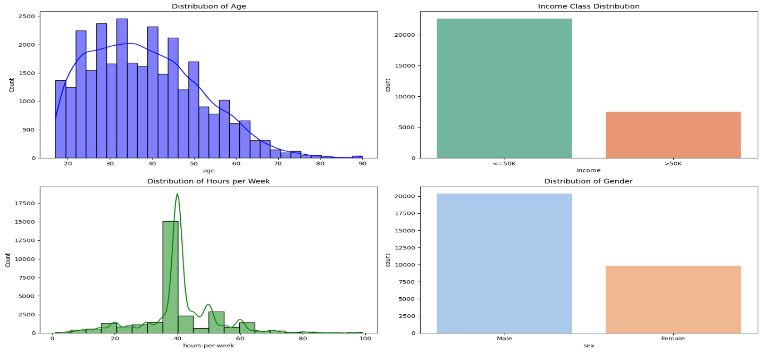
Figure 3.1: Distribution of Key Demographic Variables

Income Level by Education and Workclass
The graph (Figure 3.2) shows educational attainment and workclass status for different income levels. The dataset shows that High School graduates and Some College students make up the majority of its contents. The data reveals that people with Bachelors degrees work in above 50K salary positions which they make up 2100 of. The Private sector employs most employees who work in this field with 17500 people earning under 50K and 4900 people making above that threshold.
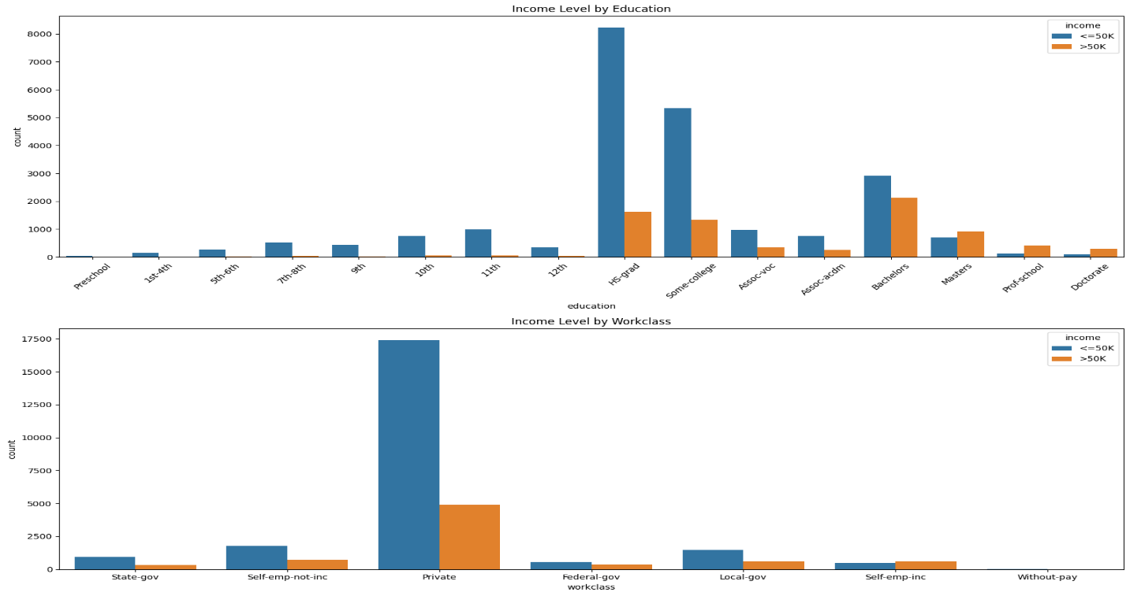
Figure 3.2: Income Level by Education and Workclass

Correlation Heatmap
Figure 3.3 displays the relationship between numerical features through correlation analysis. Education-num (0.34) and age (0.24) show the highest correlation with income whereas fnlwgt (-0.01) demonstrates a very weak connection.
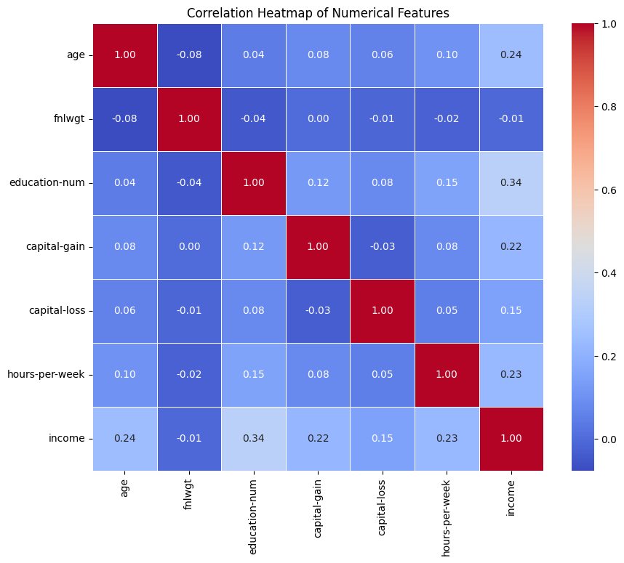
Figure 3.3: Correlation Heatmap

Age vs. Hours Worked per Week by Income
Figure 3.4 demonstrates that people who earn more than 50K work between 45 to 50 hours every week while those who earn 50K or less work approximately 35 to 42 hours. The number of hours people work starts to decrease after they reach their 60th birthday.

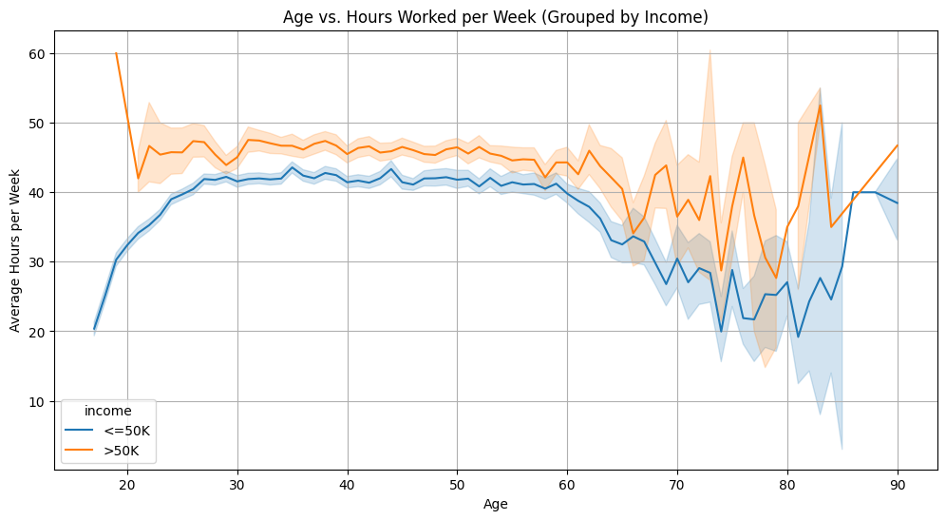
Figure 3.4: Age vs. Hours Worked per Week by Income

Chapter 4: Ethical Consideration

Personal Data and Anonymization
The Adult Census dataset contains demographic attributes such as age, education, occupation, and marital status. However, it does not include personally identifiable information like names or addresses. The dataset which originates from the 1994 United States Census has been transformed into an anonymized format that prevents identification of specific individuals.

Data Protection and Ethical Approval
The dataset meets public access requirements because it exists as an anonymized public resource therefore it does not require GDPR personal data restrictions. The project does not involve collecting new data, surveys, or human participants; therefore, formal ethical approval is not required.

Permission and Data Source
The dataset exists under the Creative Commons Attribution 4.0 (CC BY 4.0) license which Barry Becker extracted from official U.S. Census data because he collected it according to established ethical standards.

Chapter 5: Methodology

Introduction
This chapter explains the procedure used to create and assess machine learning systems which forecast income levels based on demographic information from census records. The procedure involves six stages which start with data preprocessing and proceed through feature encoding and model training and hyperparameter optimization before ending with model assessment. The researchers tested multiple classification algorithms to identify which one successfully predicted when an individual would make more than $50,000 in annual income. The researchers utilized explainable AI methods and fairness assessment to understand model behavior and determine how different demographic attributes affected prediction results.

Feature Encoding and Scaling
The dataset includes two types of attributes which are numerical and categorical. The StandardScaler method was used to standardize numerical features which included age education-num capital-gain capital-loss and hours-per-week. One-Hot Encoding was used to convert categorical attributes which included workclass education marital-status occupation relationship race sex and native-country into numerical format. The ColumnTransformer pipeline guaranteed that all necessary preprocessing procedures would be executed properly at every stage of model development.

Machine Learning Models
I used three classification algorithms to create an income prediction system for this research. The study used Logistic Regression as its baseline model because Random Forest and XGBoost could detect complex data patterns. The basic configuration of each model is presented in Table 5.1.
Table 5.1: Basic Model Configuration and Technical Rationale
Model | Library | Key Configuration | Technical Rationale
Logistic Regression | Scikit-learn | max_iter = 1000 | Logistic Regression is a linear classification algorithm commonly used as a baseline model for binary classification problems. It is computationally efficient and provides interpretable results, making it useful for comparing more complex models.
Random Forest | Scikit-learn | random_state = 42 | Random Forest is an ensemble learning method that builds multiple decision trees and aggregates their predictions. It is robust to overfitting, handles nonlinear relationships effectively, and performs well with datasets containing both numerical and categorical features.
XGBoost | XGBoost | eval_metric = logloss, random_state = 42 | XGBoost is a gradient boosting algorithm designed for high predictive performance and efficiency. It uses boosting techniques to sequentially improve weak learners and can capture complex feature interactions, making it suitable for structured tabular datasets like census data.

Hyperparameter Optimization
I used GridSearchCV to conduct hyperparameter tuning for the purpose of enhancing model predictive accuracy. The team tested multiple parameter combinations to find the best settings which would work with every algorithm. Table 5.2 shows the hyperparameter search space which the team used for their optimization process.
Table 5.2: Hyperparameter Search Space
Model | Parameter | Search Values
Logistic Regression | C | 0.1, 1.0, 10
 | Solver | lbfgs, liblinear
Random Forest | n_estimators | 100, 200
 | max_depth | 10, 20, None
 | min_samples_split | 2, 5
XGBoost | n_estimators | 100, 200
 | learning_rate | 0.01, 0.1, 0.2
 | max_depth | 3, 5, 7

Model Evaluation Metrics
The classification metrics were used to assess the model performance. The metrics show different aspects of how the model performs when testing on datasets that have uneven class distributions. The evaluation metrics used in this study are summarized in Table 5.3.
Table 5.3: Evaluation Metrics
Metric | Description | Formula
Accuracy | Measures the proportion of correctly classified instances. | $$Accuracy=\frac{TP+TN}{TP+TN+FP+FN}$$
Precision | Measures how many predicted positive cases are actually correct. | $$Precision=\frac{TP}{TP+FP}$$
Recall | Measures how many actual positive cases are correctly identified. | $$Recall=\frac{TP}{TP+FN}$$
F1-Score | Harmonic mean of precision and recall. | $$F1=2 X \frac{Precision X Recall}{Precision+ Recall}$$
Confusion Matrix | Shows the number of correct and incorrect predictions. | Visualization
ROC-AUC Curve | Illustrates the trade-off between true positive rate and false positive rate. | $$AUC= \int_{0}^{1}{TPR\left(FPR\right)d(FPR)}$$

Cross-Validation
I utilized Stratified 5-fold Cross-Validation to assess the model's ability to deliver accurate results and its ability to handle various data scenarios. The method creates five data subsets which maintain the original class proportions of the dataset. The different model performance assessments from multiple folds provide the most precise estimation of model performance.

Explainable AI (SHAP Analysis)
The model predictions can be understood through the use of SHAP values which apply to the XGBoost model. SHAP analysis enables me to determine which features affect model predictions while it shows the importance of features at both global and local levels.

Fairness Analysis
I conducted a fairness analysis to investigate how demographic factors affected model prediction accuracy. A fairness-aware model was developed through the removal of sex race age and relationship native-country attributes from the dataset. The model performance assessment involved comparing the fairness-aware model to the original model to check if both models achieved identical predictive accuracy without using protected attributes.

Chapter 6: Results

Introduction
The chapter demonstrates the results from machine learning models. The models were created to predict annual income levels. The Adult Census dataset served as the data source for this research. The model performance evaluation used four different metrics which included accuracy and precision and recall and F1-score. The study used confusion matrices and ROC curves and SHAP explainability analysis and fairness evaluation methods to investigate model performance. The research questions of the study were investigated through these model behavior analysis methods.

Model Performance Before Hyperparameter Tuning
The evaluation of models used multiple classification metrics to assess their performance before hyperparameter optimization (Table 6.1). XGBoost produced the best performance, achieving 0.87 accuracy, 0.79 precision, 0.67 recall, and an F1-score of 0.73, indicating strong predictive capability compared to the other models.
Table 6.1 Model Performance Before Hyperparameter Tuning
Model | Accuracy | Precision | Recall | F1-Score
Logistic Regression | 0.85 | 0.76 | 0.62 | 0.68
Random Forest | 0.84 | 0.71 | 0.65 | 0.68
XGBoost | 0.87 | 0.79 | 0.67 | 0.73
Figure 6.1 shows histogram of model performance
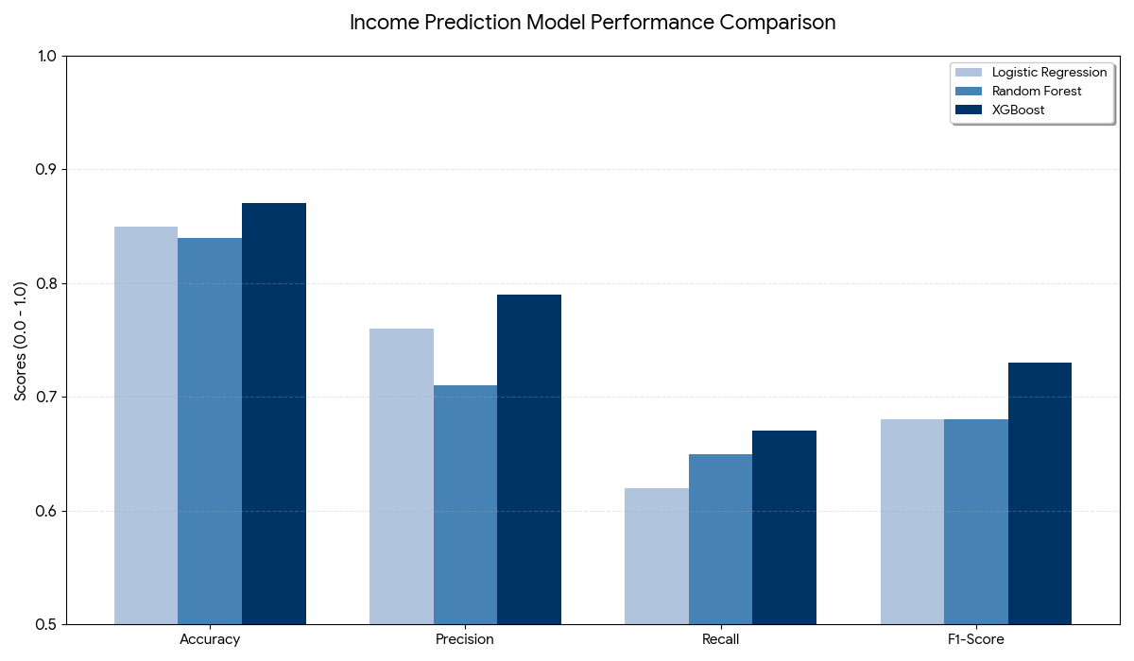
Figure 6.1: Histogram of Model Performance

Confusion Matrix Analysis
The three models show their confusion matrices through confusion matrices which Figure 6.2 displays. Logistic Regression correctly classified 4203 low-income individuals and 947 high-income individuals but misclassified 583 high-income cases. Random Forest correctly predicted 989 high-income individuals but produced slightly more classification errors.
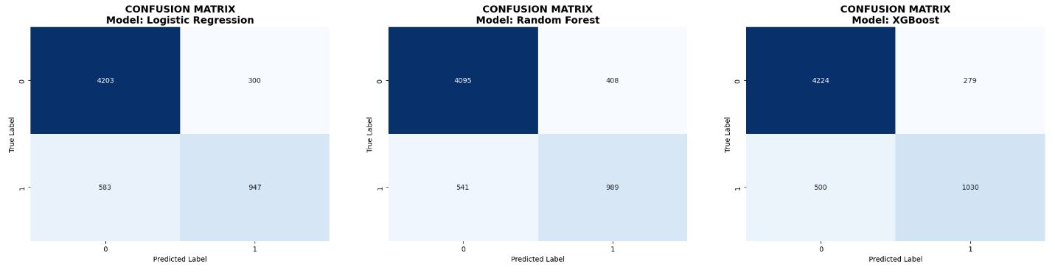
Figure 6.2: Confusion Matrix of Models
The XGBoost model achieved the best results by correctly identifying 4224 low-income and 1030 high-income individuals while producing fewer misclassifications. This demonstrates that XGBoost captures patterns in the demographic data more effectively than the other models.

ROC Curve Analysis
Figure 6.3 presents the ROC curves for all models. The ROC curve shows how the true positive rate and false positive rate interact. The AUC scores obtained were:
- Logistic Regression: 0.91
- Random Forest: 0.89
- XGBoost: 0.93
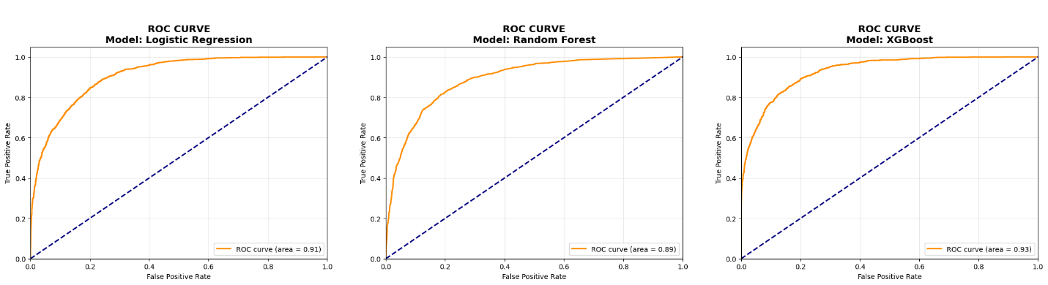
Figure 6.3: ROC Curves of the models
The higher AUC value of XGBoost proves its superior ability to differentiate between people who make more than $50K and those who make less than $50K.

Model Performance After Hyperparameter Tuning
The models showed better performance after their hyperparameter settings had been optimized (Table 6.2). XGBoost achieved its best performance results with an accuracy of 0.8747 and a precision of 0.7936 and a recall of 0.6837 and an F1-score of 0.7346 which confirmed its optimal performance.
Table 6.2 Model Performance After Hyperparameter Tuning
Model | Accuracy | Precision | Recall | F1-Score
Logistic Regression | 0.8530 | 0.7582 | 0.6170 | 0.6804
Random Forest | 0.8515 | 0.7334 | 0.6510 | 0.6898
XGBoost | 0.8747 | 0.7936 | 0.6837 | 0.7346

Cross-Validation Results

I used Stratified 5-fold cross-validation to assess both model stability and generalization performance. The results are summarized in Table 6.3.
Table 6.3 Cross-Validation Results

Model | Mean Accuracy | Mean Precision | Mean Recall | Mean F1 | F1 Std Dev
Logistic Regression | 0.8470 | 0.7341 | 0.6044 | 0.6629 | 0.0077
Random Forest | 0.8507 | 0.7351 | 0.6263 | 0.6763 | 0.0083
XGBoost | 0.8703 | 0.7787 | 0.6693 | 0.7198 | 0.0079

Explainable AI Results (SHAP Analysis)
The SHAP summary plot for the XGBoost model appears in Figure 6.4. The analysis shows marital status married-civ-spouse together with age and capital gain and education level and hours worked per week as the key factors which determine income prediction results.
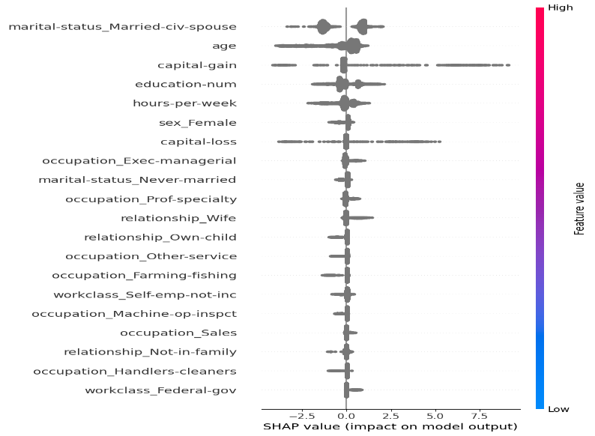
Figure 6.4: Shap Analysis
The probability of predicting income above $50K increases when capital gain and education level and working hours reach higher levels. The results show that demographic and economic traits have a strong impact on how income classification outcomes turn out.

Fairness Analysis
I conducted a fairness analysis by excluding all sensitive demographic attributes which included sex and race and age and relationship and native-country information from the dataset. The fairness-aware model achieved an accuracy of 0.8717 which is very close to the original XGBoost accuracy of 0.8747.
The model demonstrates its capability of maintaining its predictive strength while it decreases its reliance on demographic attributes which may introduce bias.

Results in Relation to Research Questions
The results obtained in this study address the research questions as follows
- The models reached strong classification results through One-Hot Encoding which transformed categorical variables into usable format for high-cardinality demographic features.
- The SHAP explainability analysis for RQ2 showed that education level and marital status and capital gain and working hours serve as the main factors which determine income prediction results.
- The fairness experiments for RQ3 showed that sensitive attributes can be removed without losing prediction accuracy which enables the creation of machine learning models that operate with integrity and minimal bias.

Chapter 7: Analysis & Discussion

Interpretation of Results
The experimental results demonstrate that machine learning models can effectively predict whether an individual earns more than $50,000 annually using demographic census data. The evaluated models showed XGBoost as the top performer because it achieved superior results across all measurement metrics which included accuracy, precision, recall, and F1-score. The model achieved an accuracy of 0.8747 after hyperparameter tuning which indicates that approximately 87% of the income predictions were correctly classified.
The confusion matrix results further demonstrate that the XGBoost model correctly identified 4224 individuals with income ≤50K and 1030 individuals with income >50K, producing fewer classification errors compared to the other models. XGBoost reached its highest AUC score of 0.93 according to the ROC analysis which demonstrated its ability to identify high-income and low-income individuals.
The results demonstrate that ensemble learning models can successfully identify the intricate connections which exist between demographic factors and educational attainment, marital status, work hour patterns and financial performance indicators.

Best Performing Model and Reasoning
The XGBoost algorithm achieved superior performance results for income classification in this study. The way XGBoost functions accounts for its superior performance results. XGBoost functions as a gradient boosting algorithm which creates multiple weak learners through sequential development to enhance prediction accuracy by fixing earlier mistakes. The model can better understand how features interact with each other through this method.
Logistic Regression establishes a linear relationship between its predictors and target variable which makes it different from other models. The model successfully functioned as a base model but it failed to handle complicated connections within the demographic information. The Random Forest algorithm achieved good performance because its ensemble design but its prediction accuracy fell short of XGBoost because boosting methods deliver superior prediction error correction.
The results prove that boosting-based ensemble methods work best with structured tabular datasets which include census demographic data.

Comparison with Previous Studies
The research outcomes demonstrate consistency with earlier studies which Chapter 2 examined. The study conducted (Islam et al., 2023) showed that XGBoost reached about 87% prediction accuracy when used with the Adult Census dataset after the model underwent optimization. The research achieved 0.8747 accuracy through XGBoost model implementation which produced results that were similar to existing literature findings.
According to other research studies (Anitha et al., 2024; Shuvo et al., n.d.) found that Random Forest and Decision Trees ensemble learning models achieve excellent results when used to predict income classification outcomes. The current study confirms this finding when Random Forest reached an accuracy of 0.8515 while maintaining its ability to compete with other systems.
The present research expands upon existing studies through its use of explainable AI methods and fairness evaluation which earlier studies did not investigate. This method shows how demographic characteristics affect the performance of income prediction models.

Feature Importance and Explainability
The SHAP analysis provided valuable insights into the demographic factors which affect income prediction results. The results showed that the most important features were marital status married-civ-spouse age capital gain education level and hours worked per week.
The finding demonstrates real-world socioeconomic patterns because people with higher education levels and longer work hours tend to earn more money. Capital gains function as financial investments which increase the value of assets that produce higher income streams.
The SHAP results show that explainable AI methods successfully demonstrate how demographic factors impact machine learning outcomes. The system enhances model prediction transparency and enables policymakers to grasp the factors which create income inequality.

Fairness and Ethical Implications
The fairness analysis investigated whether accurate predictions could still be achieved when sensitive demographic attributes were removed. The fairness-aware model achieved an accuracy of 0.8717 after I removed all attributes except for the native-country attribute which they used as the sole remaining demographic attribute.
This result suggests that machine learning models can maintain strong predictive performance even when sensitive demographic variables are excluded. More ethical and fair predictive systems achieve better results through their design methods which create better outcomes without any major negative effect on their performance.
Fairness evaluations become essential when machine learning models make decisions about hiring practices credit scoring processes and social policy development.

Limitations of the Study
The study shows promising results but need to consider several limitations. The study uses a dataset which contains 1994 United States Census demographic data but this information does not represent current market conditions and employment patterns.
The dataset provides only basic demographic information about the study participants while it lacks essential socioeconomic information, which includes regional economic data and industry development patterns. Model performance would improve through the addition of extra features.
The research implemented fairness analysis which needed to remove all sensitive information, yet future studies can use better methods for fairness-based machine learning systems.

Relation to Research Objectives and Questions
The research results achieved all goals which I established in Chapter 1.
The One-Hot Encoding method enabled machine learning models to handle high-cardinality categorical data from the census dataset according to RQ1. The models reached excellent results through their ability to classify multiple data types.
SHAP explainability analysis for RQ2 showed that demographic factors including education level, marital status, capital gain, and working hours, exerted substantial impact on income prediction outcomes
The fairness experiments showed that systems can maintain similar predictive accuracy levels while excluding all sensitive demographic data according to RQ3. The results support the creation of machine learning systems which maintain both fairness and transparency.

Practical Applications
The study results show that machine learning models can be used to study income inequality and socioeconomic trends in actual situations. Governments and policy organizations can use similar predictive models to analyze demographic patterns related to employment, education, and income distribution.
The models enable businesses and research institutions to conduct socioeconomic analysis and workforce planning and economic forecasting.
The implementation of such systems for real-world decision-making requires organizations to assess fairness and transparency and ethical implications because automated predictions have potential to perpetuate social bias.

Chapter 8: Conclusion
The research study investigated how machine learning methods can be used to forecast people"s income based on demographic information from the Adult Census dataset. The study investigated how encoding methods for categorical features and explainable AI methods together with fairness assessment methods influence the results of classification tests. XGBoost outperformed all other tested models when it achieved 0.8747 accuracy which enabled it to effectively predict income classification results. SHAP explainability analysis demonstrated that marital status, age, capital gain, education level, and working hours serve as the main features which determine income prediction results.
The fairness experiments demonstrated that systems can achieve equivalent prediction accuracy when sensitive demographic information about race, gender, and native country is removed from their data. This finding presents evidence that machine learning models can function with preserved performance while their potential bias elements are minimized through systematic design.
The findings from this research show that machine learning models serve as effective tools for examining socioeconomic trends together with income distribution patterns. The models enable policymakers and researchers together with organizations to analyze demographic patterns which connect to income distribution and employment status.
The research can be extended through future work by using current socioeconomic databases together with implementing advanced methods for fairness testing and deep learning and hybrid solution explorations. The addition of more economic indicators and regional information will enhance prediction accuracy while offering better comprehension of income inequality distribution.

Chapter 9: References
Anitha, M., Naga Malleswarao, Y., & Mohan, B. (2024). Predicting Adult Census Income with Machine Learning Techniques. International Journal for Advance Research in Science & Technology, 14(5), 5.
Chakrabarty, N., & Biswas, S. (n.d.). A Statistical Approach to Adult Census Income Level Prediction.
Chen, L.-P. (2021). Supervised Learning for Binary Classification on US Adult Income. Journal of Modeling and Optimization, 13(2), 80–91. https://doi.org/10.32732/jmo.2021.13.2.80
Islam, M. A., Nag, A., Roy, N., Dey, A. R., Ahmed Fahim, S. F., & Ghosh, A. (2023). An Investigation into the Prediction of Annual Income Levels Through the Utilization of Demographic Features Employing the Modified UCI Adult Dataset. Proceedings - 4th IEEE 2023 International Conference on Computing, Communication, and Intelligent Systems, ICCCIS 2023, 1080–1086. https://doi.org/10.1109/ICCCIS60361.2023.10425394
Shuvo, S. S., Mohanty, J., & Patel, D. (n.d.). Predicting Annual Income of Individuals using Classification Techniques.
Thapa, S. (2023). Adult Income Prediction Using various ML Algorithms. SSRN Electronic Journal. https://doi.org/https://dx.doi.org/10.2139/ssrn.4325813
Wang, J. (2022, October 27). Research on Income Forecasting based on Machine Learning Methods and the Importance of Features. https://doi.org/10.4108/eai.17-6-2022.2322745

https://archive.ics.uci.edu/dataset/2/adult

